**S-100 – Part 2b**

Portrayal RegisterContents

2a-1 Scope 1

2a-1.1 Conformance 1

2a-2 Normative references 1

2a-3 General concepts 2

2a-3.1 Register 2

2a-3.2 Feature concept dictionary 2

2a-3.3 Feature catalogue 2

2a-4 IHO Feature Concept Dictionary 2

2a-4.1 Types of registered items 2

2a-4.2 Data model of a Feature Concept Dictionary 3

2a-4.2.1 UML Model 3

2a-4.2.2 S100_RE_Register 4

2a-4.2.3 S100_CD_RegisterItem 4

2a-4.2.4 RE_ItemStatus 4

2a-4.2.5 S100_CD_FeatureConcept 5

2a-4.2.6 S100_CD_FeatureUseType 5

2a-4.2.7 S100_CD_AttributeConcept 5

2a-4.2.8 S100_CD_SimpleAttributeConcept 6

2a-4.2.9 S100_CD_QuantitySpecification 6

2a-4.2.10 S100_CD_AttributeValueType 8

2a-4.2.11 S100_CD_AttributeConstraints 9

2a-4.2.12 S100_CD_ComplexAttributeConcept 9

2a-4.2.13 S100_CD_AttributeUsage 10

2a-4.2.14 S100_CD_EnumeratedValueConcept 10

2a-4.2.15 S100_CD_InformationConcept 11

2a-4.2.16 S100_CD_AlphaCode 11

2a-4.2.17 S100_RE_ReferenceSource 12

2a-4.2.18 S100_RE_Reference 12

2a-4.2.19 S100_RE_ManagementInfo 12

Appendix 2a-A Example of a complex attribute 14

# Scope

The IHO registry will contain a number of registers, one of which will be for portrayal. A portrayal register specifies the portrayal of data. The portrayal of data is independent of the data but closely related to the data. That is the attributes within the data set drive the portrayal process, but there may be many different portrayals for the same data. The use of a register to store aspects of portrayal will significantly improve the IHO’s ability to manage and extend multiple products based on S-100 which can be made available for use in a relatively short timescale. This register will support wider use of registered items by making them publicly available and increase their visibility to potential users. This Part describes the content of the portrayal register.

## Conformance

This profile conforms to conformance class 2 of ISO 19106:2004. The following is a brief description of the specializations and generalizations where the profile differs from ISO 19126:2008.

1. A new class, S100_CD_InformationConcept is introduced.
2. New classes, S100_CD_FeatureBinding, S100_CD_InformationBinding and S100_FC_AttributeBinding are introduced.
3. A new class, S100_CD_AttributeConstraints is introduced.
4. The class FC_FeatureAttribute is specialized to be the abstract class S100_CD_Attribute.
5. New classes, S100_CD_SimpleAttributeConcept and S100_CD_ComplexAttributeConcept are introduced.
6. A new class, S100_CD_InformationRole is introduced.
7. The classes CD_InheritanceRelation, CD_FeatureOperation CD_Binding, CD_Constraint and CD_BoundFeatureAttribute are not used.

# Normative references

The following referenced documents are required for the application of this document. For dated references, only the edition cited applies. For undated references, the latest edition of the referenced document (including amendments) applies.

ISO 19135:2005, Geographic Information – Procedures for registration of items of geographic information

ISO/DIS 19126:2008, Geographic Information – Feature concept dictionaries and registers

ISO 19117:2012. Geographic Information – Portrayal

ISO 8601:2004, Data elements and interchange formats - Information interchange - Representation of dates and times

RFC 3986, *Uniform Resource Identifier (URI): Generic Syntax*. T. Berners-Lee, R. Fielding, L. Masinter. Internet Standard 66, IETF. URL: <http://www.ietf.org/rfc/rfc3986.txt> or <http://www.rfc-editor.org/info/std66>

RFC 2141, *URN Syntax*. R. Moats. IETF RFC 2141, May 1997. URL: <http://www.rfc-editor.org/info/rfc2141>

# General concepts

## Register

As described in Part 2, a register is simply a managed list. It is easier to maintain than a fixed document, because new items can be added as needed to the register, and existing items in the register can be clarified, superseded or retired. Each register item has one or more dates associated with it that indicate when changes in its status occurred. This means that a product specification, defined at a given date, may reference an item in the register at that specific point in time.

## Portrayal Register

A portrayal register specifies independent sets of definitions of point symbols, pattern symbols, complex line styles, and colour symbols. In addition, the portrayal register may be subdivided into different domains. The portrayal register may be used to develop the portrayal catalogue. Unlike the portrayal catalogue, a portrayal register does not define the portrayal rules or bind the portrayal to a feature.

Registers of portrayal information may serve as sources of reference for similar registers established by other geographic information communities as part of a system of cross-referencing.

## Portrayal catalogue

The Portrayal Catalogue contains portrayal functions that map the features to symbology it also contains symbol definitions, colour definitions, portrayal parameters and portrayal management concepts such as viewing groups. Portrayal Catalogues are described in detail in S-100 Part 9.

# IHO Portrayal Register

## Types of registered items

The following are types of items that may be registered.

1. Color Token
2. Color Profile
3. Symbol
4. Line Style
5. Area Fill
6. Font
7. Viewing Group
8. Viewing Group Layer
9. Display Mode
10. Display Plane
11. Context Parameter
12. Symbol Schema
13. Line Style Schema
14. Area Fill Schema
15. Pixmap Schema
16. Color Profile Schema
17. Cascading Style Sheet
18. Display priority

## Data model of a Portrayal Register

### 

### UML Model

The following figure shows the information model of the hydrographic portrayal register:

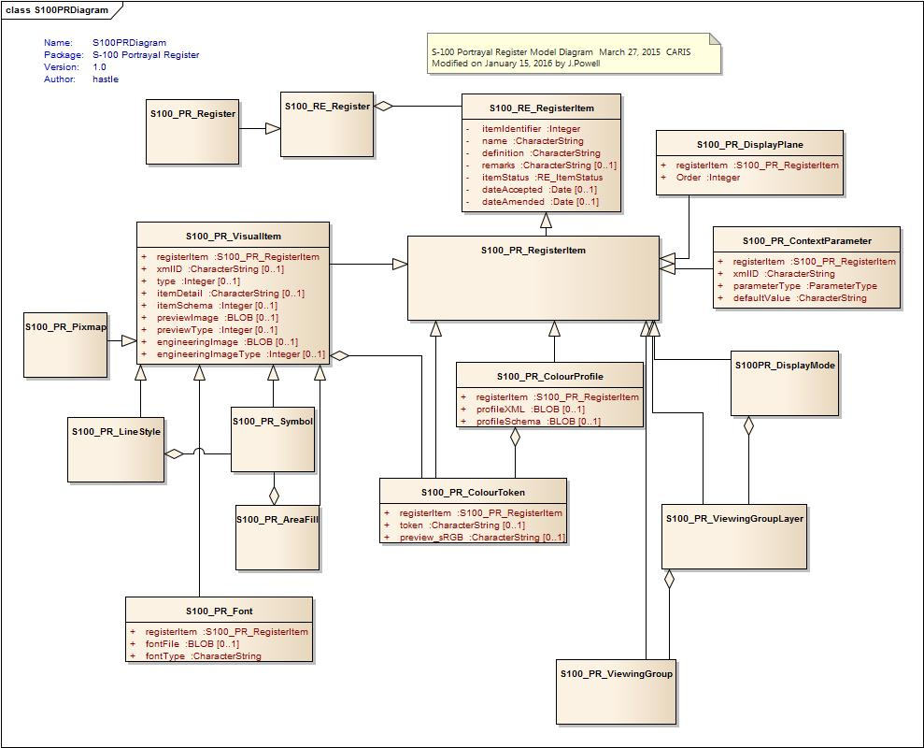

Figure 2b-1 – Portrayal Register

### 

### S100_PR_Register

This class S100_PR_Register is derived from S100_RE_Register. It is extended with an ‘owner’ and ‘domain’. The intention is that each domain or organization may have a dedicated register.

### S100_PR_RegisterItem

The class S100_PR_RegisterItem is a specialization of the class S100_RE_RegisterItem and carries the characteristics that are common to all types of registered items listed in clause 2a-4.1

### RE_ItemStatus

The class RE_ItemStatus identifies the registration status of the S100_PR_RegisterItem. Further details can be found in S-100 Part 2.

### S100_PR_ColorToken

This class is derived from S100_PR_RegisterItem. The definition of a color token as a register item of type ‘colorToken’ and carries the token string and a preview RGB value in Hex encoding. Specific color CIE values etc are stored in a color profile structure.

|  |  |  |  |  |  |
| --- | --- | --- | --- | --- | --- |
| Role Name | Name | Description | Mult | Data Type | Remarks |
| Class | S100_PR_ColorToken | Definition of a color token | - | - |  |
| Attribute | registerItem |  | 1 | S100_PR_RegisterItem |  |
| Attribute | token |  | 0..1 | CharacterString |  |
| Attribute | Preview_sRGB |  | 0..1 | CharacterString |  |

### S100_PR_ColorProfile

. This class is derived from S100_PR_RegisterItem.

|  |  |  |  |  |  |
| --- | --- | --- | --- | --- | --- |
| Role Name | Name | Description | Mult | Data Type | Remarks |
| Class | S100_PR_ColorProfile | The specific content for a colour profile as a register item of type ‘colorProfile’ | - | - |  |
| Attribute | registerItem |  | 1 | S100_PR_RegisterItem |  |
| Attribute | profileXML | XML file for the color profile | 0..1 |  |  |
| Attribute | profileSchema | Schema for the XML file of the color profile | 0..1 |  |  |

### S100_PR_VisualItem

The specific content for a register item of type ‘symbol’, ‘lineStyle’, ‘areaFill’ or ‘pixmap’ defined in PR_VisualType. The visual items each have an XML identifier string and XML document defining the item details as well as a preview image and an engineering Image with dimensions.

|  |  |  |  |  |  |
| --- | --- | --- | --- | --- | --- |
| Role Name | Name | Description | Mult | Data Type | Remarks |
| Class | S100_CD_FeatureConcept | A feature type in a feature concept dictionary | - | - |  |
| Attribute | registerItem |  | 1 | S100_PR_RegisterItem |  |
| Attribute | xmlID |  | 0..1 |  |  |
| Attribute | type |  | 0..1 | Integer | symbol, lineStyle, areaFill, or pixmap |
| Attribute | itemDetail |  | 0..1 | CharacterString |  |
| Attribute | itemSchema |  | 0..1 | Integer |  |
| Attribute | previewImage |  | 0..1 | Blob |  |
| Attribute | previewType |  | 0..1 | Integer |  |
| Attribute | engineeringImage |  | 0..1 | Blob |  |
| Attribute | engineeringImageType |  | 0..1 | Integer |  |

### S100_PR_Font

This is a specialization of S100_PR_VisualItem.

|  |  |  |  |  |  |
| --- | --- | --- | --- | --- | --- |
| Role Name | Name | Description | Mult | Data Type | Remarks |
| Class | S100_PR_Font | The specific content for a font file definition as a register item of type ‘font’. | - | - |  |
| Attribute | registerItem |  | 1 | S100_PR_RegisterItem |  |
| Attribute | fontFile |  | 0..1 | Blob |  |
| Association role | fontType |  | 0..1 | CharacterString |  |

### 

### S100_PR_DisplayPlane

S100_PR_DisplayPlane is a specialization of S100_PR_RegisterItem.

|  |  |  |  |  |  |
| --- | --- | --- | --- | --- | --- |
| Role Name | Name | Description | Mult | Data Type | Remarks |
| Class | S100_PR_DisplayPlane | The specific content for a display plane definition as a register item of type ‘displayPlane’. | - | - |  |
| Attribute | registerItem |  | 1 | S100_PR_RegisterItem |  |
| Attribute | Order |  | 1 | Integer |  |

### S100_PR_ContextParameter

S100_PR_ContextParameter is a specialization of S100_PR_RegisterItem.

|  |  |  |  |  |  |
| --- | --- | --- | --- | --- | --- |
| Role Name | Name | Description | Mult. | Data Type | Remarks |
| Class | S100_PR_ContextParameter | The specific content for a context parameter as a register item of type ‘contextParameter’. | - | - |  |
| Attribute | registerItem |  | 1 | S100_PR_RegisterItem |  |
| Attribute | xmlID |  | 1 | CharacterString |  |
| Attribute | parameterType |  | 1 | ParamterType |  |
| Attribute | defaultValue |  | 1 | CharacterString |  |